Customer Churn Prediction with ML: Improving Retention Strategies
1. Project Overview 2
1.1. Background 2
1.2. Objective 2
1.3. Technology Stack 2
1.4. Software Architecture 4
2. Dataset 5
3. Exploratory Data Analysis 6
3.1. Frequency Distribution of Churn 6
3.2. Boxplots for Numerical Features 6
3.3. Count Plots for Categorical Features 7
3.4. Outlier Detection 7
4. Feature Engineering 8
4.1. Feature Selection 8
4.2. Encoding 8
4.2.1. Label Encoding 8
4.2.2. One-Hot Encoding 8
4.3. Min-Max Scaling 8
4.4. Correlation Analysis 8
5. Model Training 9
5.1. Train Test Split 9
5.2. Model Evaluation Metrics 9
5.3. Model Selection 9
5.3.1. K Nearest Neighbours 9
5.3.2. Logistic Regression 9
5.3.3. Random Forest 9
5.3.4. Support Vector Machines 9
6. Evaluation 10
6.1. K Nearest Neighbours 10
6.2. Logistic Regression 11
6.3. Random Forest 12
6.4. Support Vector Machines 13
7. Model Improvement 13
7.1. Optimized K Nearest Neighbours 13
7.2. Optimized Logistic Regression 14
7.3. Optimized Random Forest 15
7.4. Optimized Support Vector Machines 16
8. Neural Network Model 17
8.1. Architecture 17
8.2. Results 18
9. Conclusion 19
10. Future Work 20
11. References 21

Project Overview

Background
In the fiercely competitive telecommunications industry, customer churn, the phenomenon of customers discontinuing services, poses a substantial financial challenge. With monthly losses of approximately $65 million per provider, stemming churn is imperative. The emergence of new telecom giants heightens the competition, making customer retention even more critical. Factors such as service quality, cost-effective subscription plans, content availability, and positive customer experiences play pivotal roles in retaining customers. Fortunately, comprehensive customer data, encompassing billing history, subscription plans, content costs, and network utilization, offers a 360-degree view that enables predictive analytics. This predictive power aids in identifying patterns and trends crucial for enhancing customer satisfaction and curbing churn, making it a top priority for project managers in the telecom sector. This study utilizes rough set theory, a rule-based decision-making approach, to extract churn prediction rules. Experimentation with various algorithms reveals that the rough set classification based on the genetic algorithm provides the most suitable performance, with the ability to predict potential churn customers and offer valuable insights for strategic decision-makers.

Objective
Based on the introduction the key challenge is to predict if an individual customer will churn or not. To accomplish that, machine learning models are trained based on 80% of the sample data. The remaining 20% are used to apply the trained models and assess their predictive power with regards to "churn / not churn". A side question will be, which features actually drive customer churn. That information can be used to identify customer "pain points" and resolve them by providing goodies to make customers stay.
To compare models and select the best for this task, the accuracy is measured. Based on other characteristics of the data, for example the balance between classes (number of "churners" vs. "non-churners" in data set) further metrics are considered if needed.

Technology Stack
For our project, we have carefully selected a technology stack that is tailored to meet the specific requirements and objectives. The chosen technology stack plays a crucial role in the development and execution of our project. Below, we provide an overview of the technology stack utilized:

- Integrated Development Environment (IDE)
  - Jupyter Notebook/VS Code: Our project leverages Jupyter Notebook and/or Visual Studio Code (VS Code) as the primary Integrated Development Environment (IDE). These IDEs offer powerful interactive computing environments that facilitate data exploration, analysis, and code development.
- Virtual Environment
  - We established a virtual environment to maintain a clean and isolated workspace for our project. Within this environment, we installed various essential libraries, packages, and modules necessary for our project's execution.
- Libraries and Packages
  - NumPy: NumPy is a fundamental library for numerical computations in Python. It provides support for performing mathematical operations and working with arrays, making it indispensable for scientific computing.
  - Pandas: Pandas is a widely-used library for data analysis and manipulation. It offers data structures and functions that enable efficient data handling and transformation.
  - Matplotlib: Matplotlib is a versatile plotting library that provides the tools needed to create a wide range of data visualizations. It is particularly useful for generating plots and graphs to visualize our project's results.
  - Seaborn: Seaborn is a high-level data visualization library that enhances the aesthetics and informativeness of statistical graphs. It complements Matplotlib and simplifies the creation of visually appealing data visualizations.
  - Scikit-Learn: Scikit-Learn is a comprehensive Python library for machine learning and statistical modeling. It includes tools for various tasks such as classification, regression, clustering, and dimensionality reduction. Scikit-Learn empowers our project with efficient machine learning capabilities.
  - Keras: Keras is a user-friendly, open-source Python library that facilitates the development and evaluation of deep learning models. It offers a wide range of pre-built neural network building blocks, making it an excellent choice for our deep learning tasks.
  - Warnings: The "Warnings" library is used to manage and handle warning messages within our project. It allows us to filter and ignore specific warning messages when necessary.
- Algorithms
  - K Nearest Neighbors: Fast, simple and instance-based
  - Logistic Regression: Fast and linear model
  - Random Forest: Slower but accurate ensemble model based on decision trees
  - Support Vector Machines: Slower but accurate model used here in the non-linear form
  - Feed Forward Neural Network: It is used for supervised learning in cases where the data to be learned is neither sequential nor time-dependent

By carefully selecting and integrating these technologies into our project's stack, we ensure that we have the necessary tools and resources to efficiently develop, analyze, and execute our project. This technology stack provides a solid foundation for achieving our project's goals and delivering high-quality results.

Software Architecture
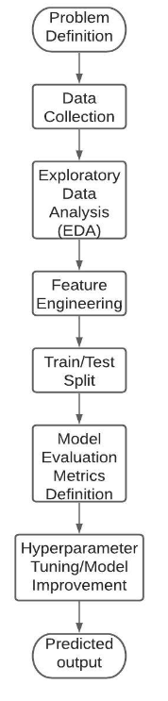

Dataset
The dataset provided contains 7,043 rows and 21 columns, representing comprehensive customer information within a telecommunications context. Each row corresponds to a unique customer record, while the columns encapsulate various attributes pertaining to these customers.

- customerID: This column serves as a unique identifier for each customer, facilitating easy tracking and referencing.
- gender: Indicates the gender of the customer, with possible values such as "Female" and "Male."
- SeniorCitizen: A binary indicator, where 0 represents a customer who is not a senior citizen, while 1 denotes a senior citizen status.
- Partner: Reveals whether a customer has a partner or not, with possible values being "Yes" or "No."
- Dependents: Indicates whether a customer has dependents, with possible values being "Yes" or "No."
- tenure: Represents the number of months a customer has been subscribed to the telecommunications service provider.
- PhoneService: A binary indicator that specifies whether a customer has an active phone service subscription, with possible values of "Yes" or "No."
- MultipleLines: Describes the status of multiple phone lines for the customer, with potential values including "No phone service," "No," and "Yes."
- InternetService: Identifies the type of internet service subscribed by the customer, which can include options such as "DSL" and "Fiber optic."
- OnlineSecurity: Indicates whether the customer has online security features, offering values like "No," "Yes," or "No internet service."
- OnlineBackup: Similar to OnlineSecurity, this column reflects the availability of online backup services with values "No," "Yes," or "No internet service."
- DeviceProtection: Represents the presence of device protection features for the customer, with values "No," "Yes," or "No internet service."
- TechSupport: Denotes the availability of technical support services for the customer, with values "No," "Yes," or "No internet service."
- StreamingTV: Indicates whether the customer has access to streaming TV services, offering values "No," "Yes," or "No internet service."
- StreamingMovies: Similar to StreamingTV, this column represents the availability of streaming movie services with values "No," "Yes," or "No internet service."
- Contract: Specifies the type of contract under which the customer is subscribed (e.g., "Month-to-month," "One year," "Two year").
- PaperlessBilling: A binary indicator revealing whether the customer opts for paperless billing, with values "Yes" or "No."
- PaymentMethod: Details the method of payment used by the customer (e.g., "Electronic check," "Mailed check," "Bank transfer," "Credit card").
- MonthlyCharges: Indicates the monthly charges incurred by the customer for the telecommunications services.
- TotalCharges: Represents the cumulative total charges incurred by the customer over their subscription tenure.
- Churn: A binary variable denoting customer churn, with "Yes" indicating that the customer has churned (i.e., discontinued the service) and "No" indicating that they are still active customers.

Exploratory Data Analysis
During the EDA phase of our research, we conducted a comprehensive examination of the dataset to gain a better understanding of customer churn. We began by visualizing the distribution of churn, which revealed an imbalance between churners and non-churners in the dataset. This class imbalance highlighted the need for resampling techniques, although we decided to maintain the imbalance for simplicity, focusing on specific evaluation metrics.

Frequency Distribution of Churn
The initial visualization displayed the frequency distribution of churn using a countplot. This graphical representation allowed us to observe the disproportionate number of non-churners compared to churners.
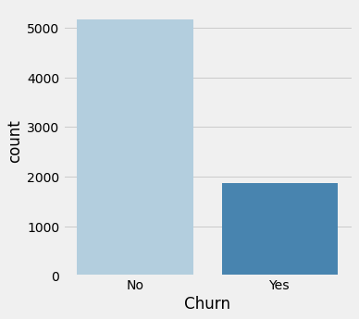

Boxplots for Numerical Features
To delve deeper into the relationship between numerical features and churn, we generated boxplots for three key variables: "tenure," "MonthlyCharges," and "TotalCharges." These boxplots provided insights into how these variables differed for churners and non-churners.
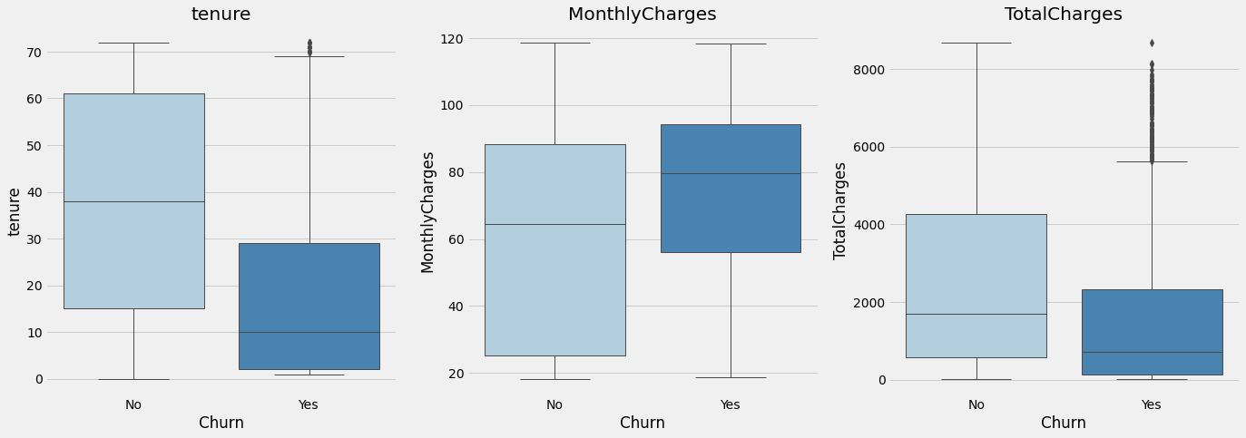
Insights from Boxplots:
- Churning customers typically had a lower median tenure, indicating they had been with the company for a shorter time.
- Monthly charges were higher for churning customers, with a narrower interquartile range compared to non-churners.
- TotalCharges, a result of tenure and MonthlyCharges, required individual examination to provide insights.

Count Plots for Categorical Features
We also created count plots for several categorical features to analyze their relationship with churn. These features included "SeniorCitizen," "Contract," "Partner," "Dependents," "PaymentMethod," and "InternetService."
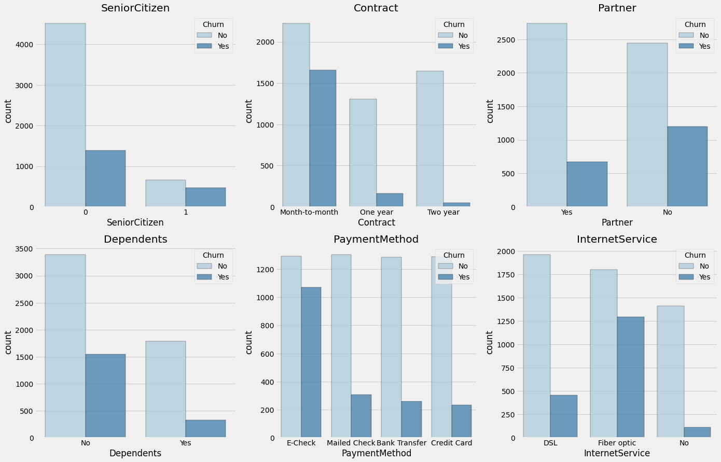
Insights from Countplots:
- Senior citizens exhibited a notably higher churn rate compared to non-senior customers.
- Month-to-month contracts had a considerably higher churn rate compared to other contract durations.
- Customers without partners or dependents were more likely to churn.
- The "Electronic check" payment method was associated with a significantly higher churn rate.
- Customers with InternetService including fiber optic experienced a substantially higher churn rate.

Outlier Detection
Finally, we conducted an outlier check using the Interquartile Range (IQR) method for numerical features (tenure, MonthlyCharges, and TotalCharges). Fortunately, no outliers were detected using this method, and therefore, no adjustments were made to the data.

Feature Engineering

Feature Selection
The "CustomerID" column was removed from the dataset since it had been deemed irrelevant for predicting customer churn.

Encoding

Label Encoding
Certain categorical columns, such as 'Partner,' 'Dependents,' 'Churn,' 'PhoneService,' and 'PaperlessBilling,' were transformed using label encoding, where 'Yes' was mapped to 1, and 'No' was mapped to 0. Additionally, the 'gender' column was encoded as 'Female' to 1 and 'Male' to 0.

One-Hot Encoding
Several categorical columns, including 'MultipleLines,' 'InternetService,' 'OnlineSecurity,' 'OnlineBackup,' 'DeviceProtection,' 'TechSupport,' 'StreamingTV,' 'StreamingMovies,' 'Contract,' 'PaymentMethod,' and 'Number_AdditionalServices,' had been subjected to one-hot encoding. This technique had converted categorical values into binary columns, making them suitable for machine learning algorithms.

Min-Max Scaling
Numerical features like 'tenure,' 'MonthlyCharges,' and 'TotalCharges' had undergone Min-Max scaling. This process had scaled these features to a common range, ensuring that they had a consistent impact on the prediction model.

Correlation Analysis
After feature engineering, a correlation analysis was performed to assess the relationships between each feature and the target variable 'Churn.' This analysis had helped identify which features had a significant impact on predicting customer churn.
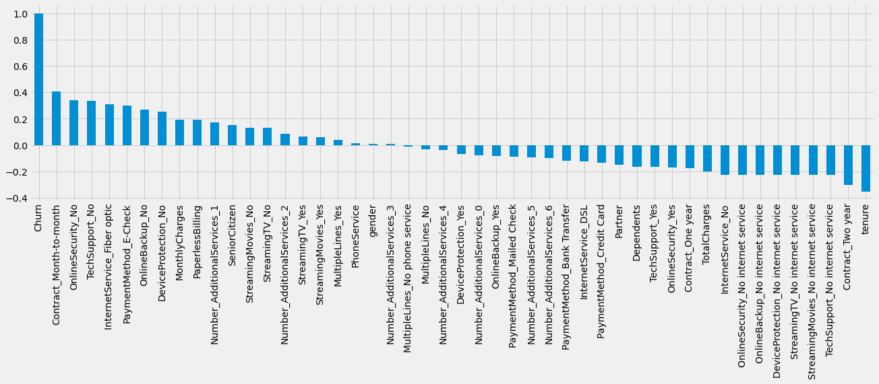
The results of the correlation analysis had shown that 'Churn' had a strong positive correlation with the 'Contract_Month-to-month' column, indicating that customers with month-to-month contracts were more likely to churn. Conversely, the correlation with the 'gender' column had been negligible, suggesting that gender had little influence on customer churn. Additionally, 'tenure' had exhibited a strong negative correlation with churn, implying that longer-tenured customers were less likely to churn.

Model Training

Train Test Split
For conduction of model training and testing steps, the data set is split into 80% training data and 20% test data. The "Churn" column is defined as the class (the "y"), the remaining columns as the features (the "X").

Model Evaluation Metrics
We assessed model performance using key metrics:

- Feature Weights: Identifying top contributing features in our models.
- Confusion Matrix: Evaluating true and false predictions against actual values.
- Accuracy Score: Measuring overall correctness in predictions.
- ROC Curve and AUC: Analyzing diagnostic ability and class separability.
- Precision-Recall Curve and AUC: Handling class imbalances by focusing on precision and recall.
- F1 Score: Finding a balance between precision and recall.
These metrics offered a comprehensive view of model effectiveness, aiding in model selection and improvement.

Model Selection

K Nearest Neighbours
K Nearest Neighbours is recognized as a fast, simple, and instance-based algorithm. In the realm of Customer Churn Prediction, KNN proves to be an efficient choice for its ability to quickly classify customers based on their proximity to other customers in the dataset.

Logistic Regression
Logistic Regression is another fast and linear model that was explored during the model selection process. It offers simplicity and interpretability, making it a valuable tool in churn prediction scenarios where a straightforward understanding of the relationships between variables is essential.

Random Forest
Random Forest, though relatively slower compared to KNN and Logistic Regression, emerges as an accurate ensemble model based on decision trees. Its ability to mitigate overfitting while maintaining predictive accuracy makes it a robust choice in cases where model performance is a top priority.

Support Vector Machines
Support Vector Machines, in their non-linear form, were also considered despite being slower in execution. They are appreciated for their accuracy, particularly when dealing with complex, non-linear patterns in customer churn data. SVMs were deemed suitable for scenarios where model accuracy outweighs computational efficiency.

Evaluation

K Nearest Neighbours
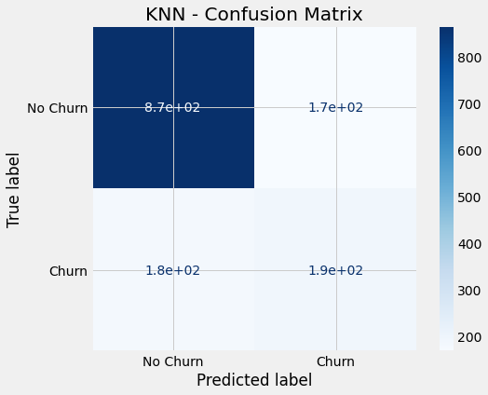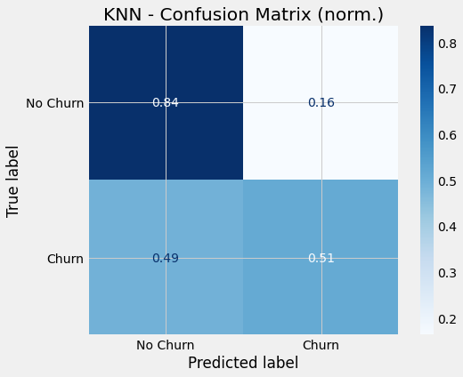
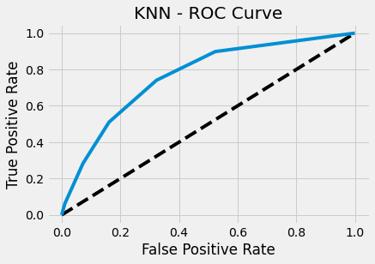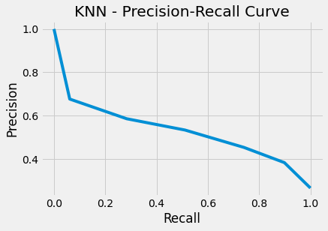
AUC Score (ROC): 0.764
F1 Score: 0.522
AUC Score (PR): 0.531

Logistic Regression
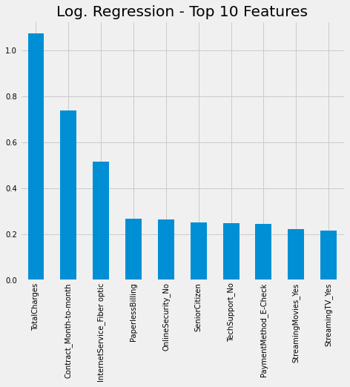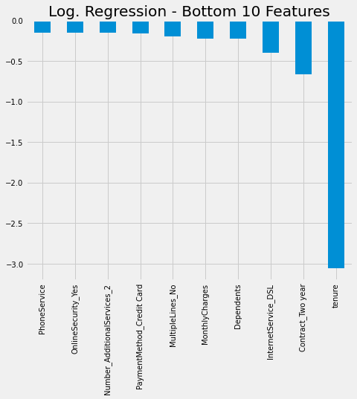
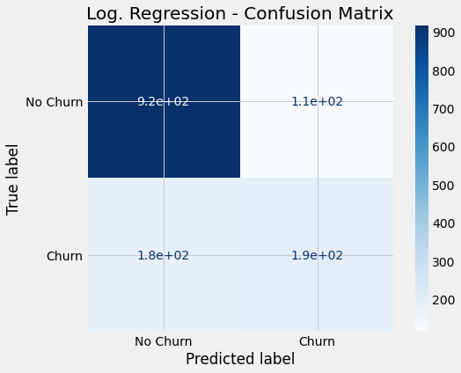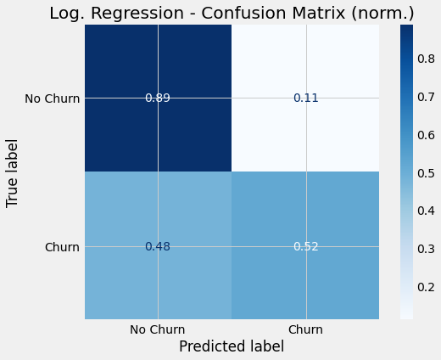
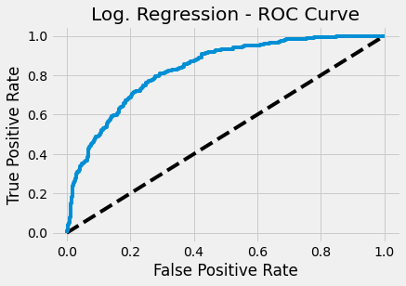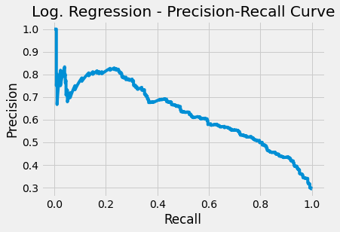
Accuracy Score Test: 0.792
Accuracy Score Train: 0.807 (as comparison)
AUC Score (ROC): 0.832
F1 Score: 0.57
AUC Score (PR): 0.63

Random Forest
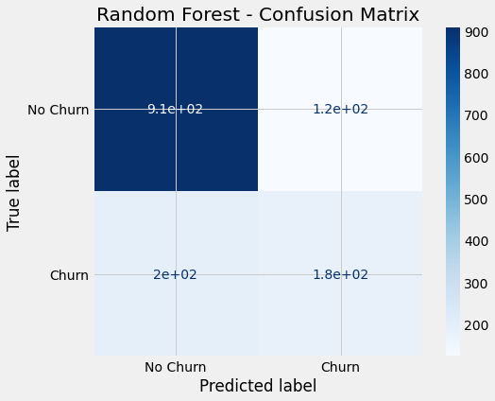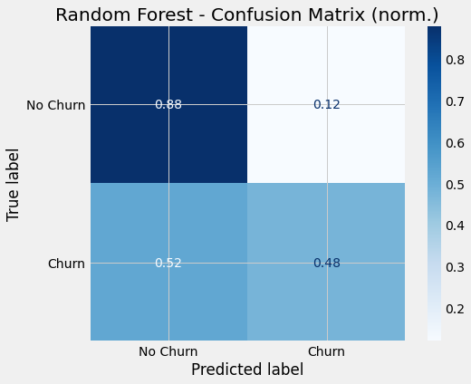
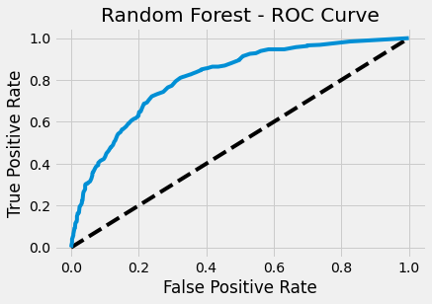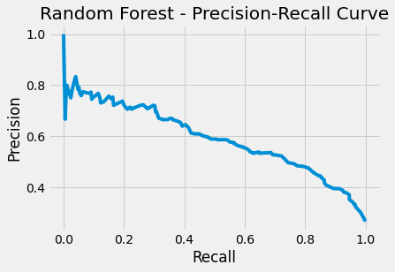
Accuracy Score Test: 0.775
Accuracy Score Train: 0.998 (as comparison)
AUC Score (ROC): 0.808
F1 Score: 0.53
AUC Score (PR): 0.591

Support Vector Machines
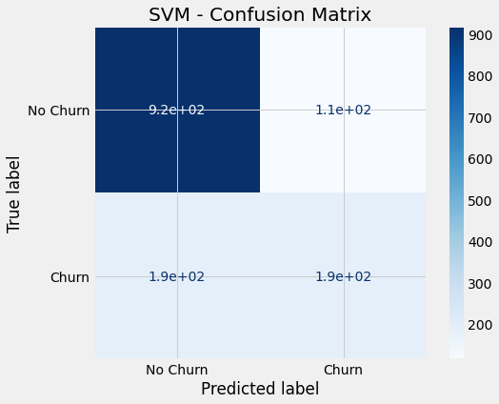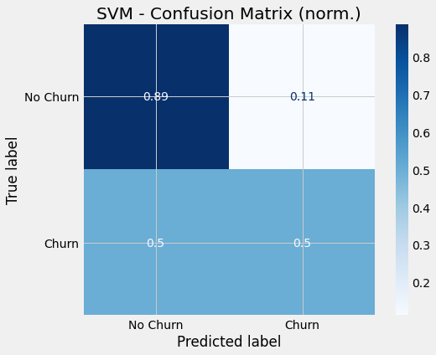
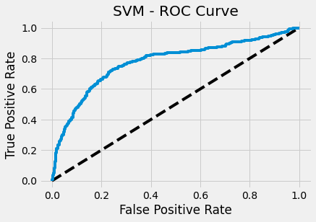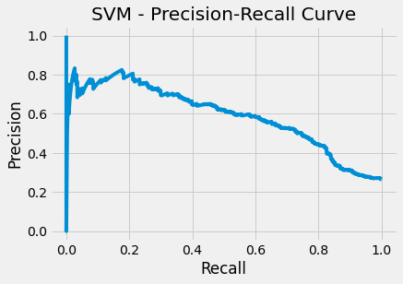
Accuracy Score Test: 0.786
Accuracy Score Train: 0.819 (as comparison)
AUC Score (ROC): 0.776
F1 Score: 0.554
AUC Score (PR): 0.589

Model Improvement
In the pursuit of enhancing the performance of our customer churn prediction model, several strategies were employed to optimize various machine learning algorithms. These optimizations were aimed at achieving the highest predictive accuracy and improving the overall model robustness.

Optimized K Nearest Neighbours
In the case of K Nearest Neighbours (KNN), a critical aspect of model improvement was the determination of the optimal number of neighbors (k). To accomplish this, GridSearchCV, a powerful hyperparameter tuning technique, was employed. GridSearchCV systematically explored a range of possible k values to identify the configuration that resulted in the best model performance. This meticulous process allowed us to fine-tune the KNN algorithm and obtain an optimal setting that maximized predictive accuracy.
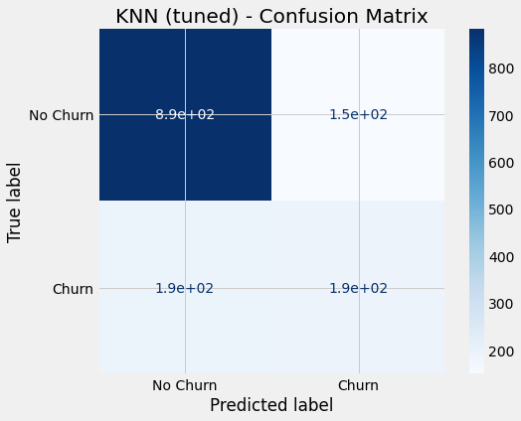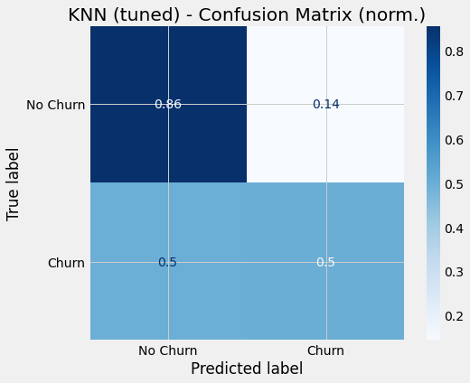
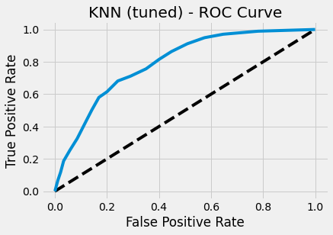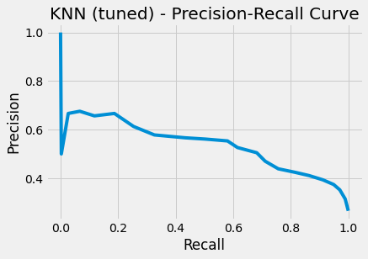
Accuracy Score Test: 0.763
Accuracy Score Train: 0.806 (as comparison)
AUC Score (ROC): 0.791
F1 Score: 0.53
AUC Score (PR): 0.537

Optimized Logistic Regression
Logistic Regression, another fundamental algorithm in our churn prediction model, underwent optimization to enhance its effectiveness. To achieve this, GridSearchCV was utilized once more. However, in the case of Logistic Regression, the focus extended beyond finding the optimal model configuration. It also involved the selection of the most suitable regularization technique, namely L1 or L2 regularization.

L1 regularization was employed to eliminate the influence of non-meaningful features by driving their corresponding coefficients to zero. This process effectively filtered out irrelevant information, leading to a simplified and more interpretable model. On the other hand, L2 regularization was applied to dampen the impact of strong patterns that the model might have captured during training. This helped in reducing overfitting and ensuring the model's robustness against noise in the data.
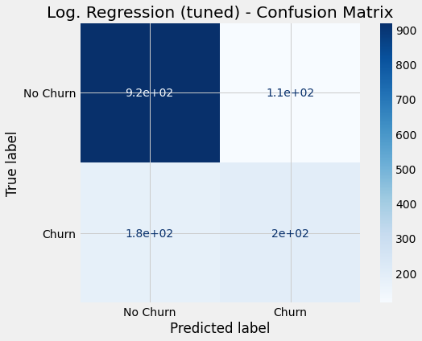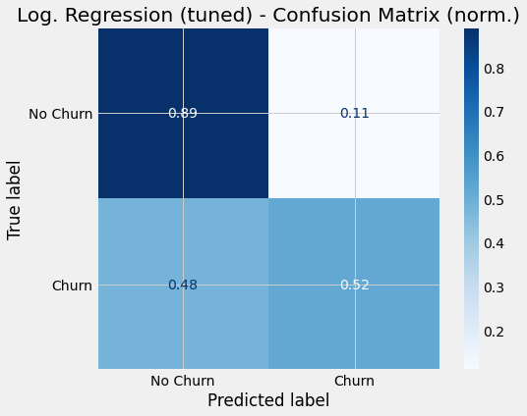
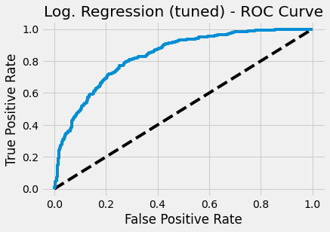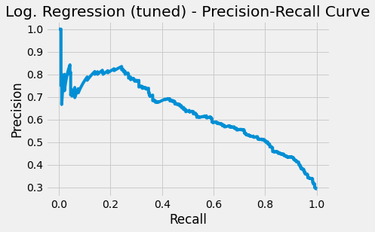
Accuracy Score Test: 0.793
Accuracy Score Train: 0.807 (as comparison)
AUC Score (ROC): 0.832
F1 Score: 0.573
AUC Score (PR): 0.632

Optimized Random Forest
The Random Forest algorithm was another integral component of our customer churn prediction system, and its optimization involved a different approach. We leveraged RandomizedSearchCV, a technique that systematically explored hyperparameter combinations by sampling from predefined ranges.

In this context, RandomizedSearchCV efficiently optimized several critical hyperparameters, including the number of estimators (n_estimators), the maximum number of features considered for splitting (max_features), the maximum depth of individual trees (max_depth), the criterion for splitting nodes, and whether bootstrapping was employed. This comprehensive exploration allowed us to identify an ensemble of decision trees that collectively produced superior predictive performance.
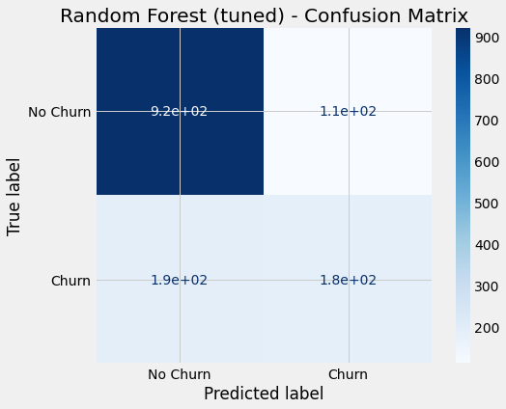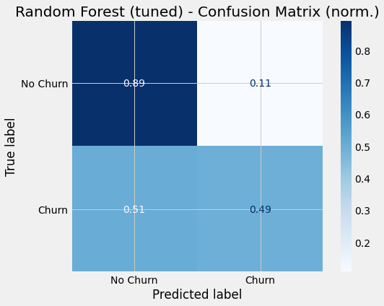
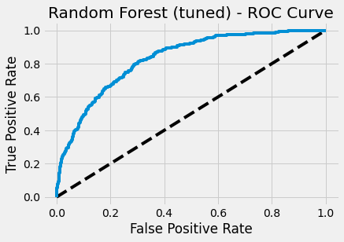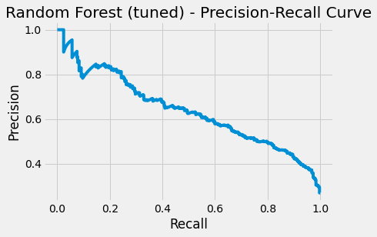
Accuracy Score Test: 0.788
Accuracy Score Train: 0.886 (as comparison)
AUC Score (ROC): 0.828
F1 Score: 0.554
AUC Score (PR): 0.638

Optimized Support Vector Machines
Support Vector Machines (SVMs) are known for their efficacy in classification tasks, but their performance heavily depends on the selection of hyperparameters. In the case of SVMs, GridSearchCV was again the method of choice for optimization.

GridSearchCV systematically evaluated different values of the hyperparameter C, which controls the trade-off between maximizing the margin around the support vectors and minimizing classification errors. By determining the optimal C value, we were able to fine-tune the SVM model, ensuring that it achieved the best possible separation of churn and non-churn instances.
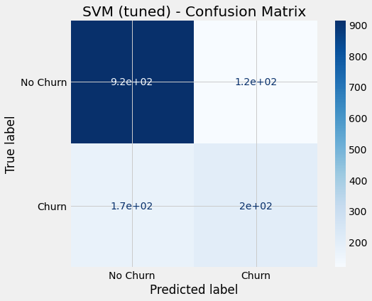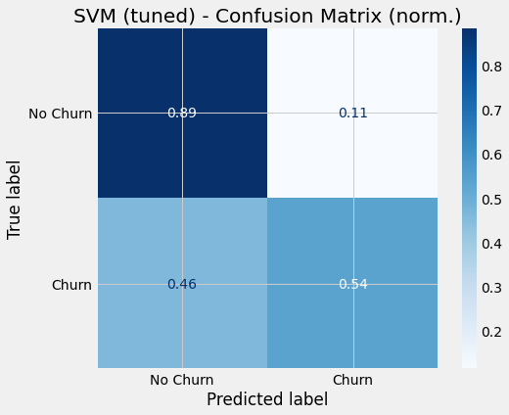
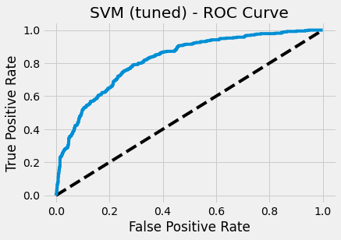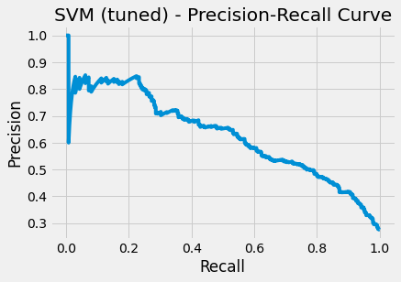
Accuracy Score Test: 0.794
Accuracy Score Train: 0.803 (as comparison)
AUC Score (ROC): 0.820
F1 Score: 0.581
AUC Score (PR): 0.628

Neural Network Model
Although the data set is relatively small and neural networks generally require lots of training data to develop meaningful prediction capabilities, a simple neural network is employed for a quick comparison to the other approaches.

Architecture
The neural network model adopted a sequential architecture, comprising several layers. The layers and their associated characteristics were as follows:

- Dense Layer (dense):
  - Output Shape: (None, 1024)
  - Parameters: 49,152
- Dropout Layer (dropout):
  - Output Shape: (None, 1024)
  - Parameters: 0
- Dense Layer (dense_1):
  - Output Shape: (None, 1024)
  - Parameters: 1,049,600
- Dropout Layer (dropout_1):
  - Output Shape: (None, 1024)
  - Parameters: 0
- Dense Layer (dense_2):
  - Output Shape: (None, 1)
  - Parameters: 1,025

Total trainable parameters in the model: 1,099,777
Non-trainable parameters: 0

Results
The model's performance was assessed based on both training and testing data, with the following key metrics:
- Best Model (During Training):
  - Training Score: 0.416
  - Training Accuracy: 0.802
  - Testing Score: 0.436
  - Testing Accuracy: 0.796
- Final Model (After Training):
  - Training Score: 0.089
  - Training Accuracy: 0.958
  - Testing Score: 1.788
  - Testing Accuracy: 0.746
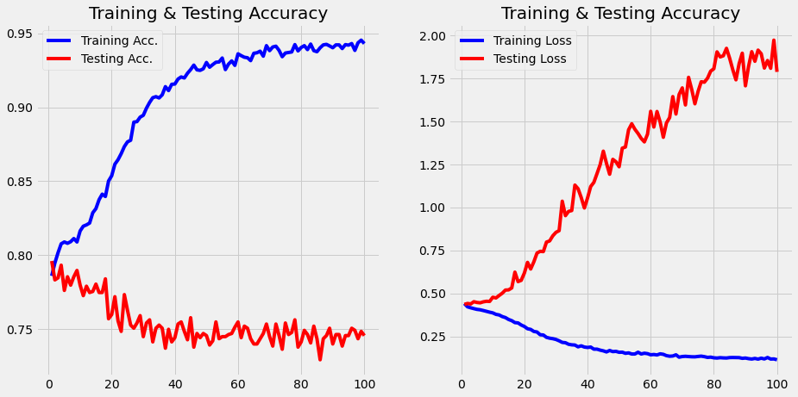
Accuracy: 0.796020
ROC AUC: 0.829348
Precision: 0.669261
Recall: 0.459893
F1 Score: 0.545166

Conclusion
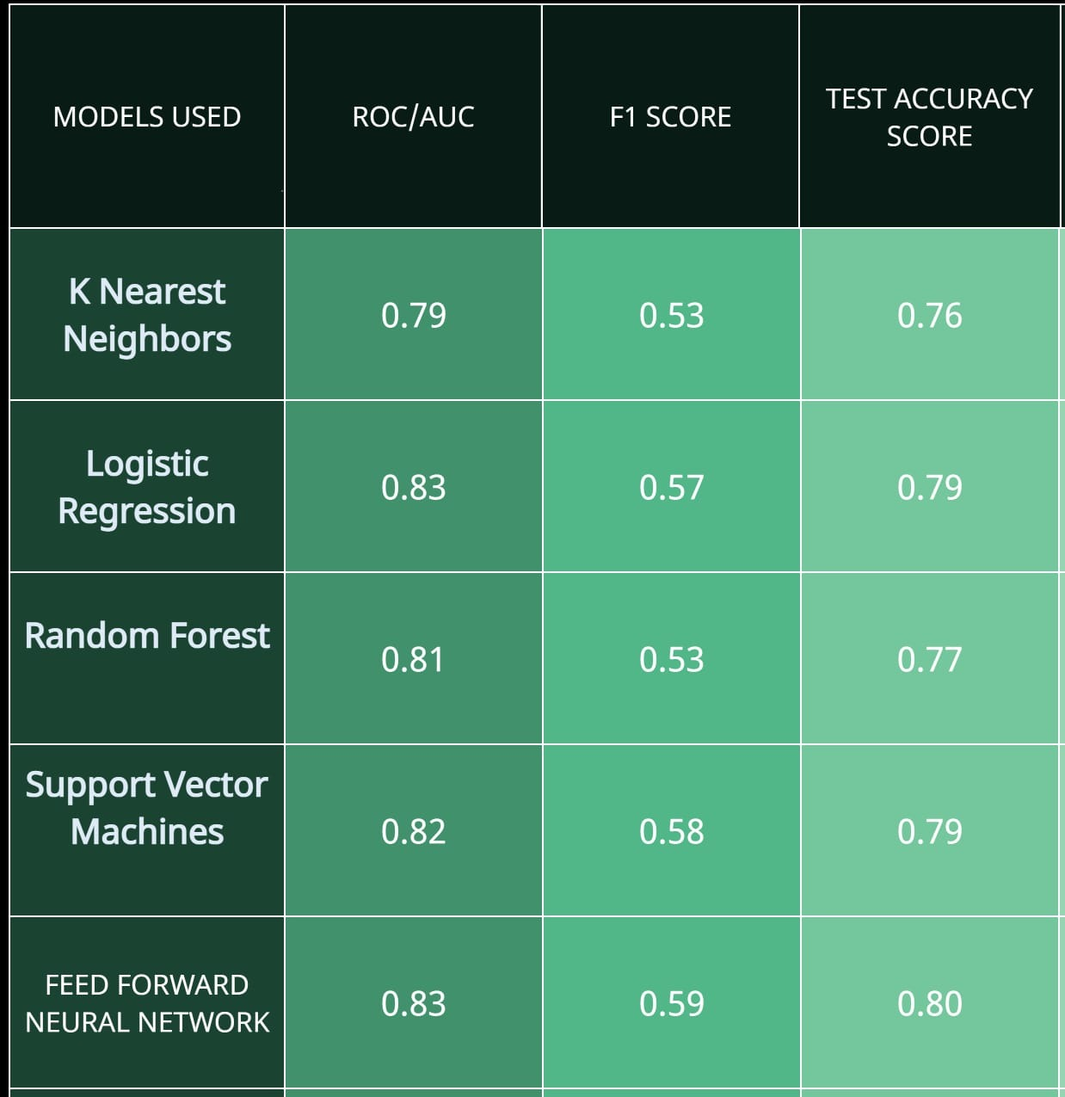
In this comprehensive study, we embarked on a data science journey with a deep dive into churn prediction, using a meticulously selected dataset and a range of advanced modeling techniques. Our primary objective was to develop a model capable of accurately identifying potential churners, a critical task for businesses seeking to enhance customer retention.

Our analysis commenced with Exploratory Data Analysis (EDA), shedding light on the dataset's characteristics and unveiling potential outliers. Subsequently, we engaged in extensive Feature Engineering to enhance the quality of our input data, a crucial step in model development.

Model training involved a rigorous process of model selection, where we evaluated four prominent algorithms: K Nearest Neighbors, Logistic Regression, Random Forest, and Support Vector Machines. Through this comparative analysis, we identified the Neural Network as the top-performing model, achieving an impressive accuracy of 0.7996 on the test set.

To account for the class imbalance issue inherent in churn prediction, we emphasized F1 scores, aiming for a balance between precision and recall. The Neural Network also excelled in this aspect, with an F1 score of 0.5948, further affirming its superiority.

Future Work
In the realm of Customer Churn Prediction in the Telecom Industry, there are opportunities for future work that could significantly enhance model accuracy and effectiveness. Telecom companies often possess extensive untapped data resources that can be harnessed using advanced neural networks.

One avenue for improvement lies in the expansion of data sources. Telecom companies have access to a wealth of customer-related information, including extended customer profiles and detailed transaction data from CRM systems. Operational data, especially regarding network services, is also available. Incorporating these additional data sources could provide valuable insights into customer behavior, improving churn prediction accuracy.

Another area for exploration is the scale of available data. Telecom companies typically have access to much larger datasets than the modest example of 7,000 churn and non-churn events. Leveraging these larger datasets, neural networks can be trained to recognize intricate patterns, leading to higher prediction accuracies.

Enhancing accuracy is essential for identifying and retaining valuable customers effectively, particularly when churn can be avoided through targeted retention campaigns. Therefore, improving accuracy is vital for maximizing the cost-effectiveness of customer retention efforts.

In addition to expanding data sources and dataset sizes, improving data quality is another area for future research. Capturing a broader spectrum of customer-related parameters, such as temporal and geographic aspects, can provide a more comprehensive view of customer behavior and potential churn triggers.

References
- I. Ullah, B. Raza, A. K. Malik, M. Imran, S. U. Islam and S. W. Kim, "A Churn Prediction Model Using Random Forest: Analysis of Machine Learning Techniques for Churn Prediction and Factor Identification in Telecom Sector," in IEEE Access, vol. 7, pp. 60134-60149, 2019, doi: 10.1109/ACCESS.2019.2914999.
- Ahmad, A.K., Jafar, A. & Aljoumaa, K. Customer churn prediction in telecom using machine learning in big data platform. J Big Data 6, 28 (2019). https://doi.org/10.1186/s40537-019-0191-6
- Umayaparvathi, V., and K. Iyakutti. "A survey on customer churn prediction in telecom industry: Datasets, methods and metrics." International Research Journal of Engineering and Technology (IRJET) 3.04 (2016).
- Amin, Adnan & Shehzad, Saeed & Khan, Changez & Anwar, Sajid. (2015). Churn Prediction in Telecommunication Industry Using Rough Set Approach. Studies in Computational Intelligence. 572. 83-95. 10.1007/978-3-319-10774-5_8.
- N. Lu, H. Lin, J. Lu and G. Zhang, "A Customer Churn Prediction Model in Telecom Industry Using Boosting," in IEEE Transactions on Industrial Informatics, vol. 10, no. 2, pp. 1659-1665, May 2014, doi: 10.1109/TII.2012.2224355.

